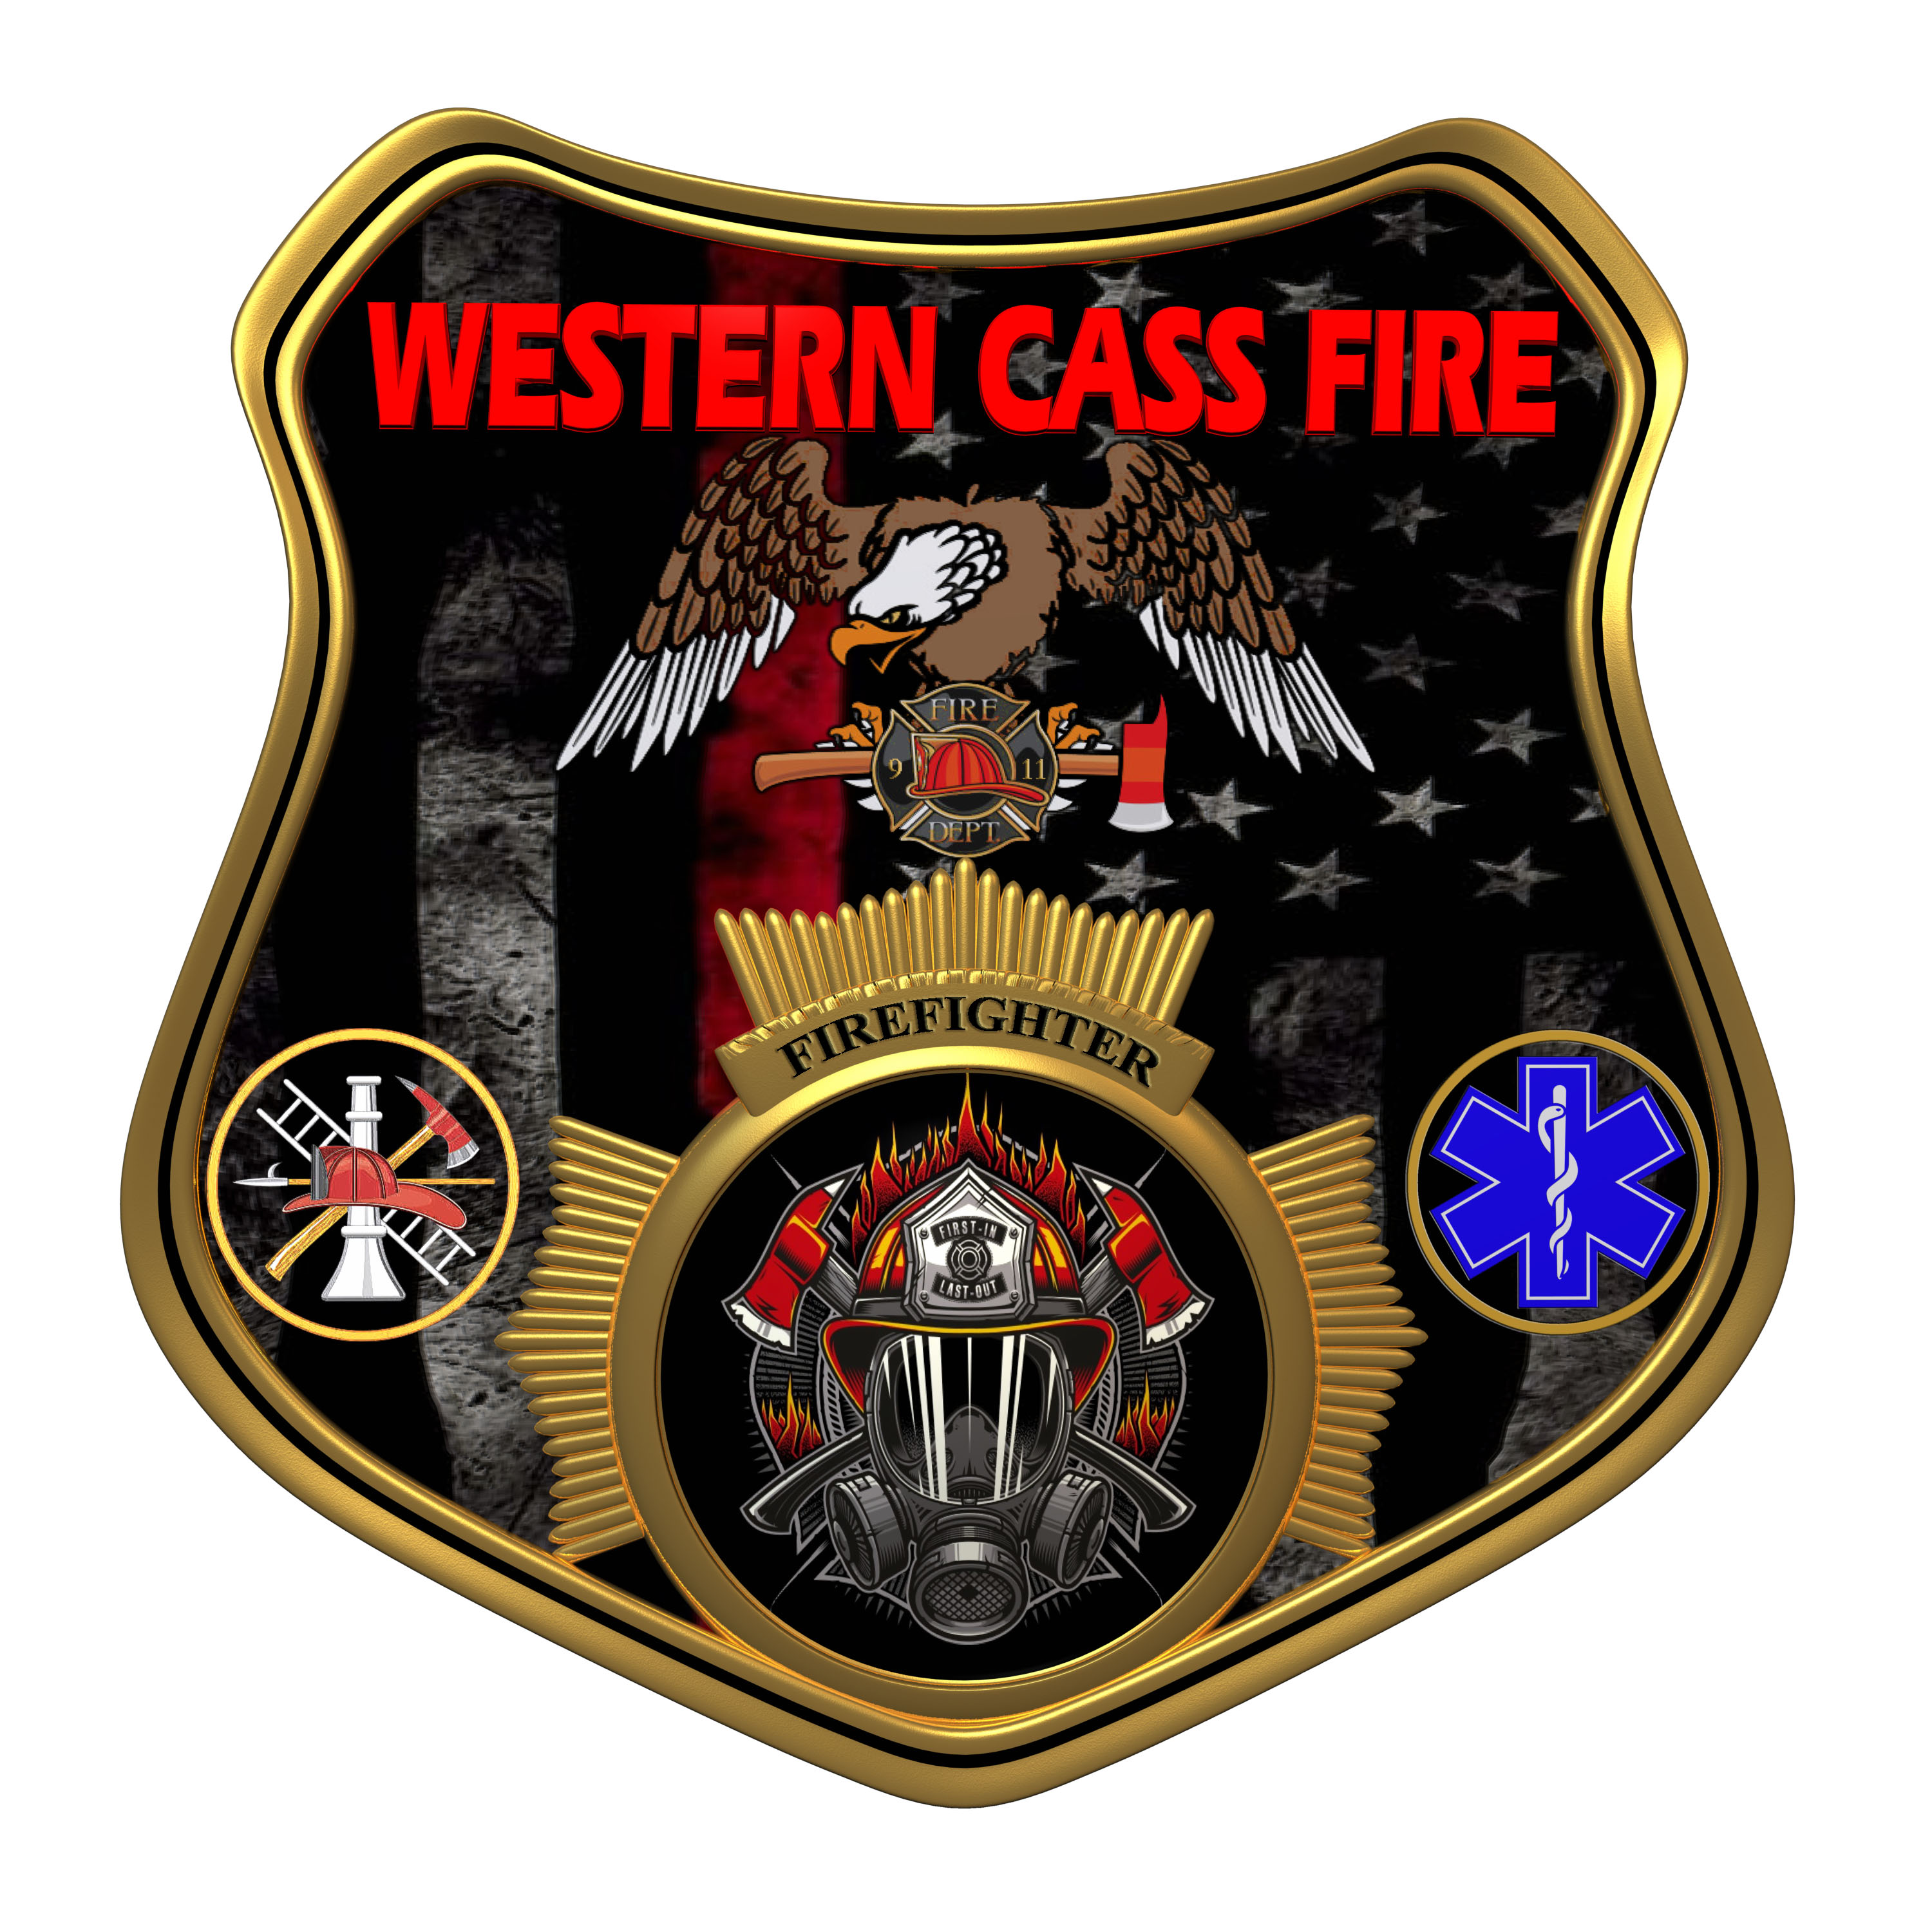 | Tentative Agenda  Western Cass Fire Protection District  Regular Session Meeting  Wednesday, May 17 2023, at 7:00 pm  Fire Headquarters  5 S. Rogers Road, Cleveland, MO 64734  In Person Only  Discussion Protocols and Organization Rules for Meetings:  Questions from the public must be in writing with the following information: Name, Phone #, Physical Address, Email Address.  Board Members will be limited to 3 minutes for discussion of agenda items, twice per item, and discussion of items will last no more than 10 minutes per item.
- Call to Order by the Secretary
2) Roll Call (Quorum)
a) President Sue Hosterman (2019-2025)
b) Vice Chair John Webb (2022- 2027)
c) Director Tom Reintjes (2023- 2029)
d) Director Kerri VanMeveren (2020-2026)
e) Director Darvin Schildknecht (2021-2027)
3) Approve the minutes from March 30 2023, and the Incoming and Outgoing minutes of April 18, 2023
4) Directors Reports (Written Form)
a) Treasurer Report
b) Chief Report
5) New Business
a) Equipment Replacement
b) Credit Cards
c) ACH
d) Checks and Banking
e) Email for Director Reintjes
f) Training Seminar Expenses
6) Unfinished Business
a) Medical Director Payments
b) Attorney Payment
c) Live In Program Contract
d) Facility Manager Contract
7) Closed Session - Personnel
Personnel matters are confidential until such time as they may be made public by the Board of Directors, and the nondisclosure of such records outweighs the public interest in disclosure of the records as according to RSMo 610.021(3)(13).
8) Adjourn

