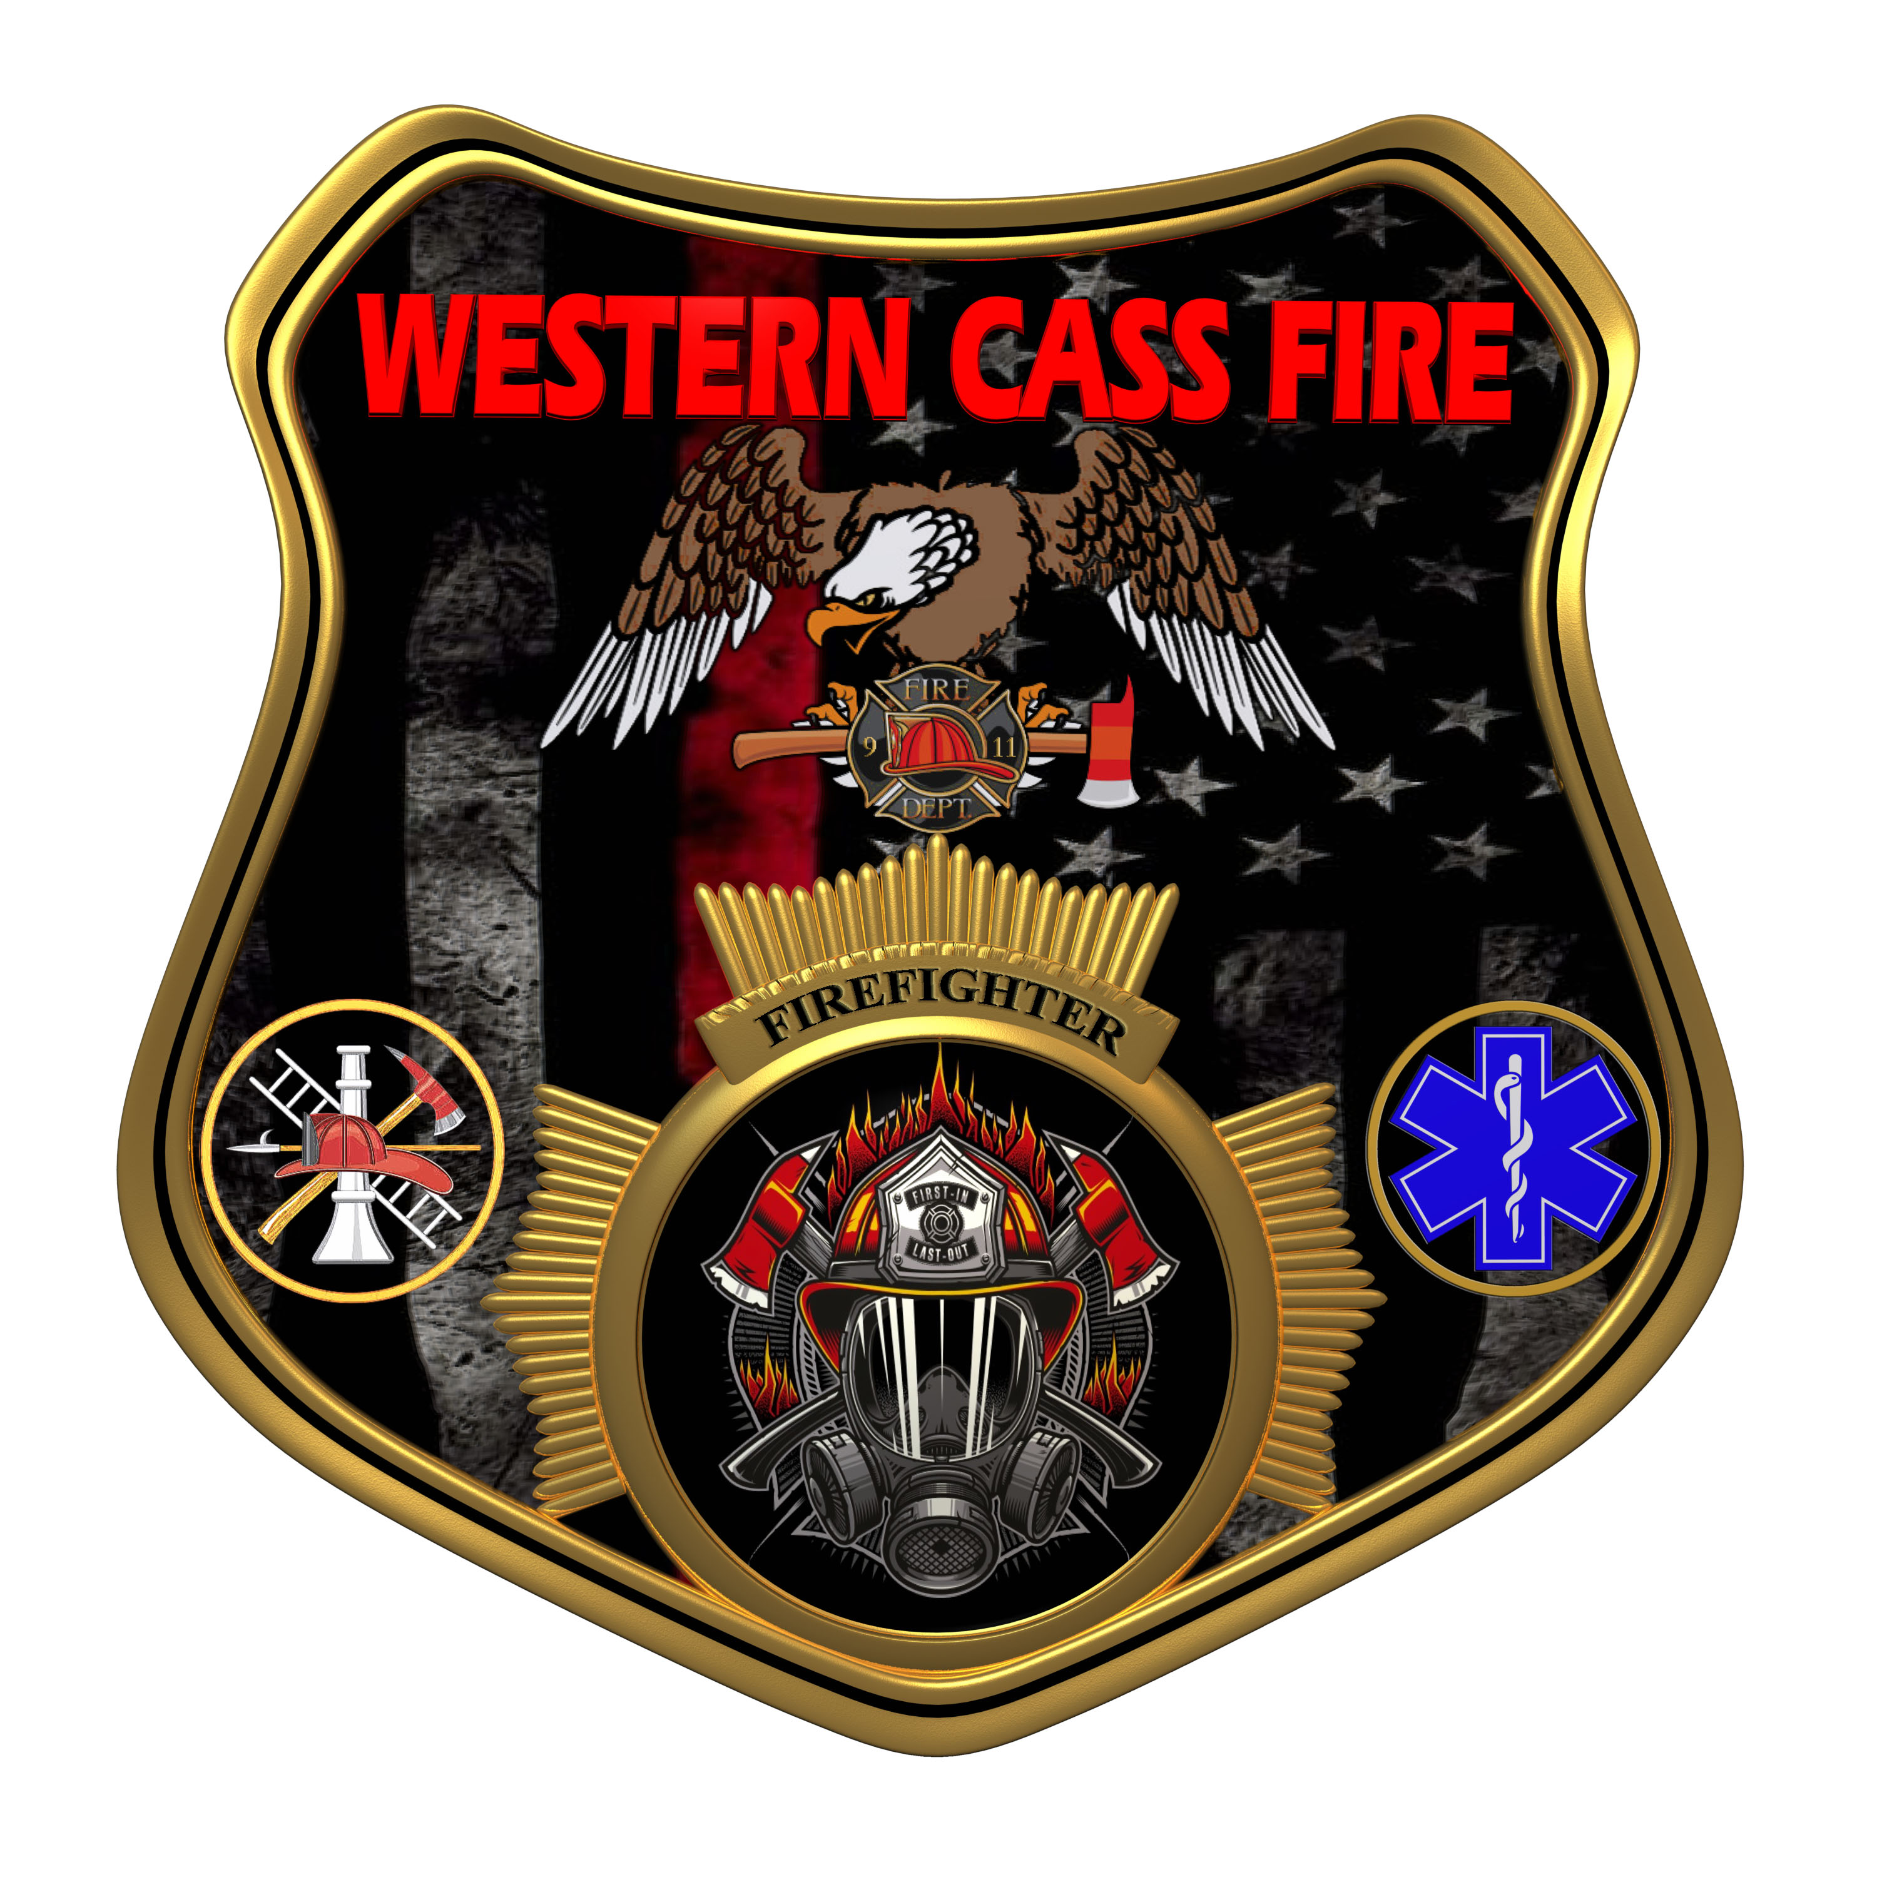 | Tentative Agenda  Western Cass Fire Protection District  Regular Session Meeting  Wednesday, February 15, 2023, at 7:00 pm  Fire Headquarters  5 S. Rogers Road, Cleveland, MO 64734  In Person Only  Discussion Protocols and Organization Rules for Meetings:  Questions from the public must be in writing with the following information: Name, Phone #, Physical Address, Email Address.  Board Members will be limited to 3 minutes for discussion of agenda items, twice per item, and discussion of items will last no more than 10 minutes per item.
- Call to Order by the Secretary
- Pledge of Allegiance
- Roll Call (Quorum)
a) President and Chair John Webb (2022- 2027)
b) Vice Chair Marty Hardman (2022- 2023)
c) Director Sue Hosterman (2019-2025)
d) Director Kerri VanMeveren (2020-2026)
e) Director Darvin Schildknecht (2021-2027)
- Adopt and Approve Wednesday, February 15, 2023 Tentative Agenda
5) Approve Minutes
a) 12-21-2022 Minutes
b) 1-18-2023 Minutes
c) 2-02-2023 Minutes
d) 2-08-23 Minutes
6) Reports (Submit Written)
7) New Business
a) Insurance Policy
b) District Legal Counsel
c) Fire Chief Personnel Management Request
d) Gusto Approval
8) Unfinished Business
a) Xero Cancellation
9) Adjourn

