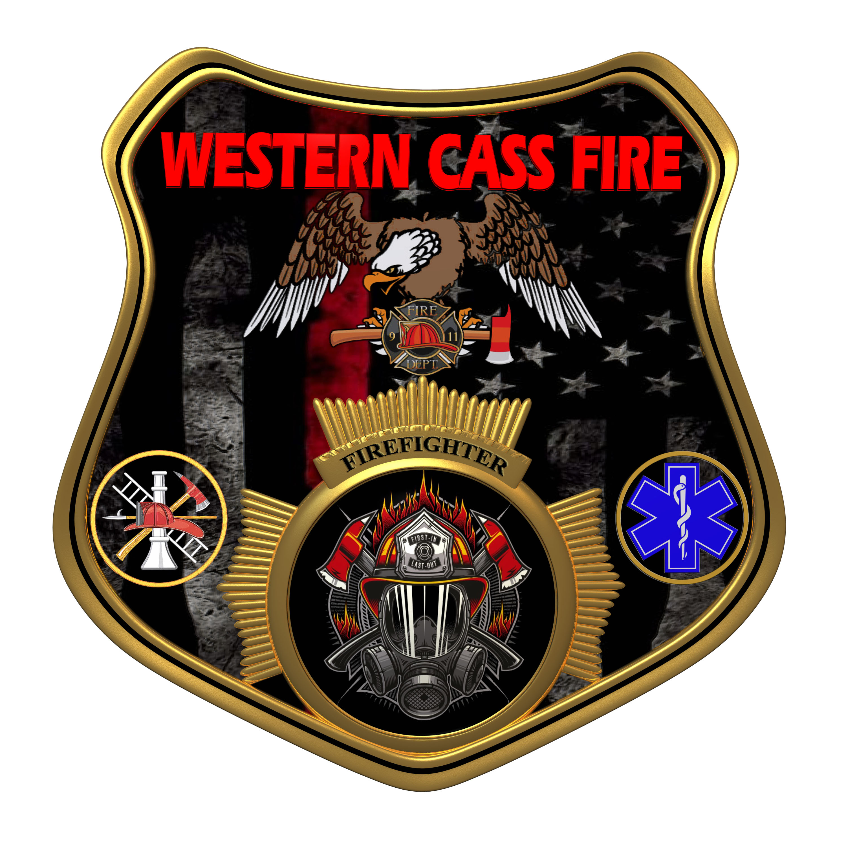 | Tentative Agenda  Western Cass Fire Protection District  Regular Session  Wednesday, December 21, 2022, at 7:00 pm  Fire Headquarters  5 S. Rogers Rd., Cleveland, MO 64734  In Person Only  Discussion Protocols and Organization Rules for Meetings:  Questions from the public must be in writing with the following information: Name, Phone #, Physical Address, Email Address.  Board Members will be limited to 3 minutes for discussion of agenda items, twice per item, and discussion of items will last no more than 10 minutes per item.
- Call to Order by the Secretary
- Pledge of Allegiance
- Roll Call (Quorum)
a) President and Chair John Webb (2022- 2027)
b) Vice Chair Marty Hardman (2022- 2023)
c) Director Sue Hosterman (2019-2025)
d) Director Kerri VanMeveren (2020-2026)
e) Director Darvin Schildknecht (2021-2027)
- Adopt and Approve Wednesday, December 21, 2022 Tentative Agenda
- Personal Appearances / Public Comments
- Approve Minutes
a) Approve the Special Session minutes of November 16, 2022
b) Approve the Closed Session Minutes of October 19, 2022
7) Reports
a) Directors Submit Written Reports
b) Treasurer Report Written Report
C) Chief Report Written Report
8) Unfinished Business
a) Battery Checks for the Emergency Backups
b) Test of Emergency System Station 1
c) Bay Lights Station 2 Reimbursement
d) Status on Insurance Policy
9) New Business
a) Nullification of Previous Policies
b) Smart Pro Termination
c) Dishwashers
d) Station 2 Faucett
e) Chief Recommendations on Residency Program
f) Chief Recommendations on Fire School Funding
g) Chief Recommendations on Firefighters Assoc of MO
h) Chief Recommendations on Jacks’s Winter Fire School
i) District Manager's Recommendations on Credit Card Limits
j) District Manager's Recommendations on Phone Service Changes
k)Removal of Unapproved Versions of Minutes in Director's Reports Retroactive
l) Removal of Director Schildknecht pursuant to RSMo 321.190

10) Adjourn

