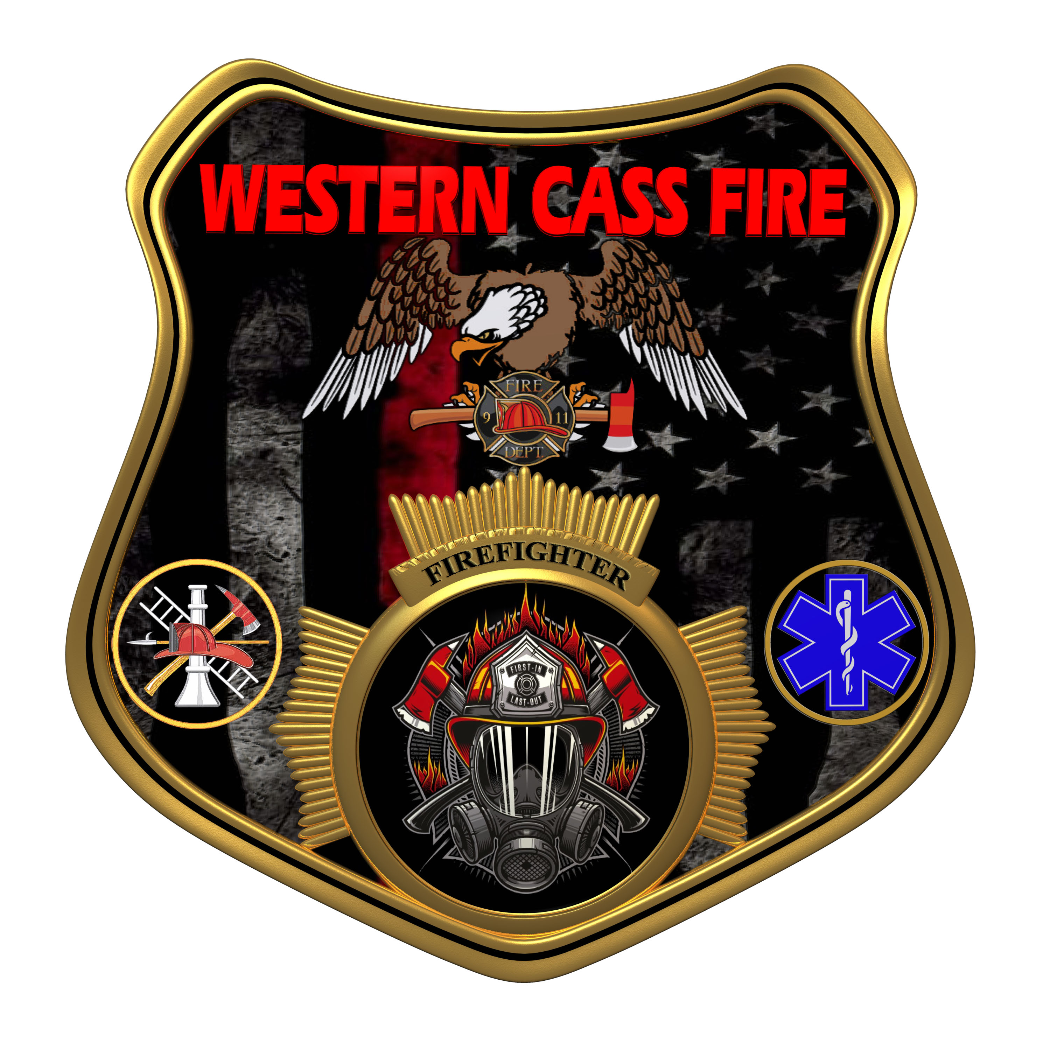 | Tentative Agenda  Western Cass Fire Protection District  Regular Session Meeting Outgoing  Tuesday, April 18, 2023, at 7:00 pm  Fire Headquarters  5 S. Rogers Road, Cleveland, MO 64734  In Person Only  Discussion Protocols and Organization Rules for Meetings:  Questions from the public must be in writing with the following information: Name, Phone #, Physical Address, Email Address.  Board Members will be limited to 3 minutes for discussion of agenda items, twice per item, and discussion of items will last no more than 10 minutes per item.
- Call to Order by the Secretary
- Pledge of Allegiance
- Roll Call (Quorum)
a) President and Chair John Webb (2022- 2027)
b) Vice Chair Marty Hardman (2022- 2023)
c) Director Sue Hosterman (2019-2025)
d) Director Kerri VanMeveren (2020-2026)
e) Director Darvin Schildknecht (2021-2027)
- Agendas
Adopt and Approve Tuesday, April 18, 2023 Tentative Agenda Outgoing
5) Approve Minutes
a) Approve Feb 15, 2023 Regular Session Minutes
b) Approve the February 28, 2023 Litigation Subcommittee Closed Session Minutes
c) Approve March 15, 2023 Regular Session Minutes
d) Committee Appointment to Approve This Meeting's Minutes
6) Special Orders of the Day
Declaration of Election Results
7) Departing Remarks
8) Personal Appearances/Public Comment
10) Adjourn Sin Die

