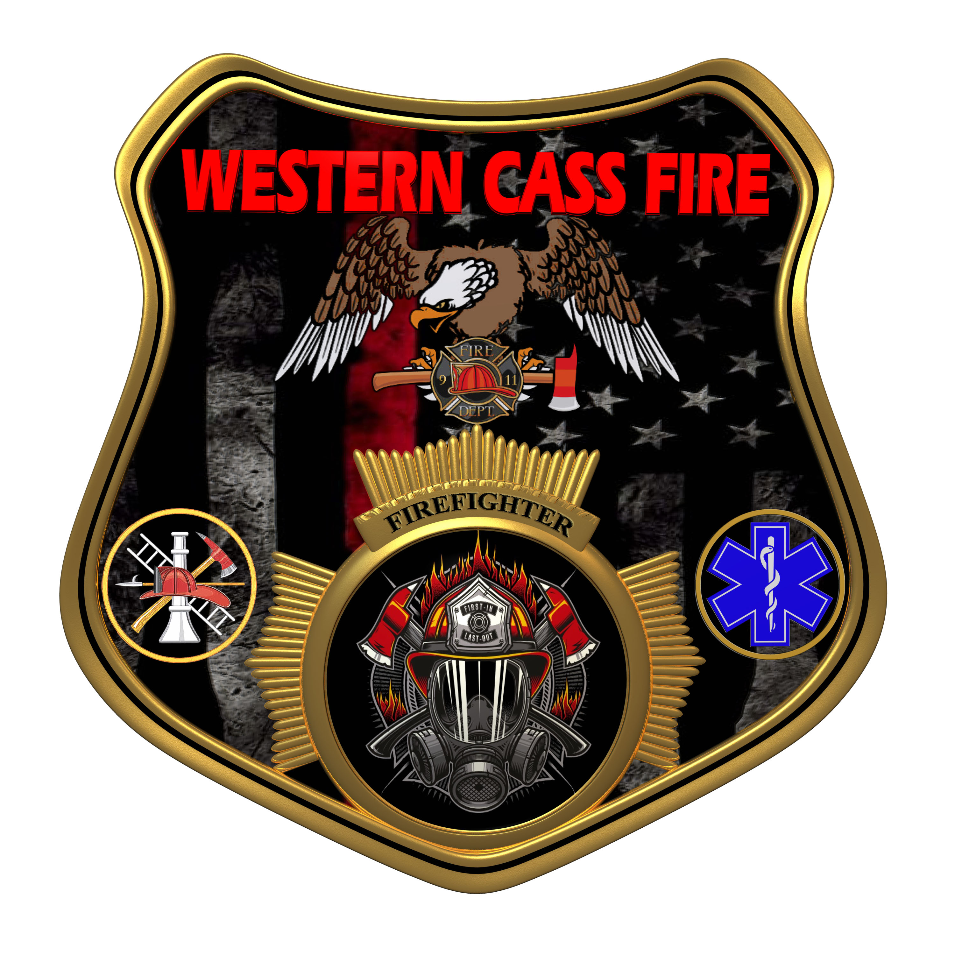 | Closed Session Minutes  Western Cass Fire Protection District  Regular Session Meeting  Wednesday, July 19 2023, at 7:00 pm  Fire Headquarters  5 S. Rogers Road, Cleveland, MO 64734
- Call to Order by the Secretary - 7:00 P.M.
- Pledge of Allegiance
3) Roll Call (Quorum)
a) President Sue Hosterman (2019-2025) Present
b) Vice Chair John Webb (2022- 2027) Present
c) Director Tom Reintjes (2023- 2029) Present
d) Director Kerri VanMeveren (2020-2025) Present
e) Director Darvin Schildknecht (2021-2027) Present
4) Approve the July 19, 2023 Regular Session Meeting Agenda and Additions.
President Hosterman made a motion to approve the July 19, 2023 Regular Session Tentative Agenda with the date to the minute approval corrected to June 21, 2023 and it passed.
President and Chair Sue Hosterman - Aye
Vice Chair John Webb - Aye
Director Tom Reintjes - Aye
Director Kerri VanMeveren - Nay
Director Darvin Schildknecht - Nay

5) Public Comments
6) Approve the minutes from the Regular Session Meeting of June 16 2023 - No Action Taken
7) Director Reports (Written Form - Concerning Activities on Behalf of the District Only)
a) Treasurer Report
b) Chief Report
8) New Business
a) Teresa Hawkins
Teresa Hawkins informed the board that she will take legal action against Kerri VanMeveren and Darvin Schildknecht because they are spreading lies about her around town. They have told residents that she is committing nepotism with the district, and that the district is paying her money under the table to promote the recall election against VanMeveren and Schildknecht.
b) Sunshine Request Policy
Vice Chair Webb made a motion to approve a new Sunshine Policy and to adopt the new policy pending approval of the district legal counsel, and it passed.
President and Chair Sue Hosterman - Aye
Vice Chair John Webb - Aye
Director Tom Reintjes - Aye
Director Kerri VanMeveren - Nay
Director Darvin Schildknecht - Nay
c) Website
President Hosterman made a motion to allow Marty Hardman to update the district website as a volunteer, and it passed.
President and Chair Sue Hosterman - Aye
Vice Chair John Webb - Aye
Director Tom Reintjes - Aye
Director Kerri VanMeveren - Nay
Director Darvin Schildknecht - Nay
9) Unfinished Business
a) Equipment Purchases
Vice Chair Webb made a motion to approve the purchase of new gloves and helmets for district personnel at a cost of no more than $6000.00, and it passed.
President and Chair Sue Hosterman - Aye
Vice Chair John Webb - Aye
Director Tom Reintjes - Aye
Director Kerri VanMeveren - Aye
Director Darvin Schildknecht - Aye
b) Credit Card - No Action Taken
c) EMT School
President Hosterman made a motion to approve spending $3000.00 for two firefighters to take the EMT class online, and it passed.
President and Chair Sue Hosterman - Aye
Vice Chair John Webb - Aye
Director Tom Reintjes - Aye
Director Kerri VanMeveren - Aye
Director Darvin Schildknecht - Aye
d) Attorney Payment
President Hosterman made a motion to pay $3150.00 to Carl Scarborough for the second quarter of 2023 for legal services, and it passed.
President and Chair Sue Hosterman - Aye
Vice Chair John Webb - Aye
Director Tom Reintjes - Aye
Director Kerri VanMeveren - Aye
Director Darvin Schildknecht - Aye
e) Mowing Services Payment - No Action Taken
f) President Hosterman made a motion to go into closed session to discuss personnel hiring, and it passed.
President and Chair Sue Hosterman - Aye
Vice Chair John Webb - Aye
Director Tom Reintjes - Aye
Director Kerri VanMeveren - Aye
Director Darvin Schildknecht - Aye

10) Closed Session - Personnel
Personnel matters are confidential until such time as they may be made public by the Board of Directors, and the nondisclosure of such records outweighs the public interest in disclosure of the records as according to RSMo 610.021(3)(13).

a) Vice Chair Webb made a motion to accept Chief Johnson's recommendation to hire Mike Day as a volunteer firefighter pending background check and drug screen, and it passed.
President and Chair Sue Hosterman - Aye
Vice Chair John Webb - Aye
Director Tom Reintjes - Aye
Director Kerri VanMeveren - Abstain (refused to vote)
Director Darvin Schildknecht - Aye
b) President Hosterman made a motion to return to open session and adjourn, and it passed.
President and Chair Sue Hosterman - Aye
Vice Chair John Webb - Aye
Director Tom Reintjes - Aye
Director Kerri VanMeveren - Aye
Director Darvin Schildknecht - Aye
11) Adjourn - 7:45 P.M.

