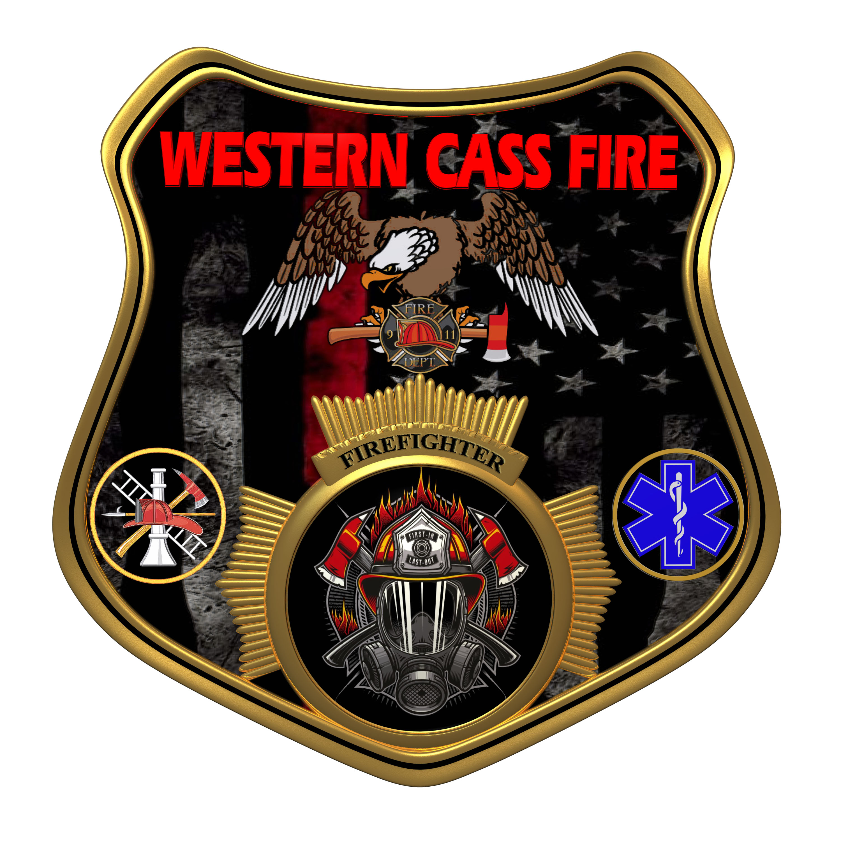 | Western Cass Fire Protection District  Special Session Meeting Minutes  Thursday, February 02, 2023  Fire Headquarters  5 S. Rogers Road, Cleveland, MO 64734
- Call to Order by the Secretary 6:00 P.M.
- Pledge of Allegiance
- Roll Call (Quorum)
a) President and Chair John Webb (2022- 2027) Present
b) Vice Chair Marty Hardman (2022- 2023) Present
c) Director Sue Hosterman (2019-2025) Present
d) Director Kerri VanMeveren (2020-2026) Present
e) Director Darvin Schildknecht (2021-2027) Present
- President Webb made a motion to approve the Thursday, February 02, 2023 Tentative Agenda with the day corrected to Thursday and it passed.
President and Chair John Webb - Aye
Vice Chair Marty Hardman - Aye
Director Sue Hosterman - Aye
Director Kerri VanMeveren - Aye
Director Darvin Schildknecht - Aye

5) New Business
a) Insurance
1) Director Hosterman made a motion to extend the closing date to accept bids for district insurance until Monday, February, 6 2023 and it passed by consent agenda with no dissention.
2) Director Hosterman scheduled another special meeting for February 08, 2023 to open sealed bids in closed session.
3) Note: Director VanMeveren asked for the sealed bids to be opened and sent to the directors for review by email, so that the decision could be made on February 08 instead of opening them on that date.
4) Note: Director Hardman informed her that doing so would be against state statutes for sealed bids, but VanMeveren again asked for them to be opened and emailed prior to the February 08 meeting.
5) Note: Directors Hardman, Hosterman, and Webb made it very clear that the bids would not be opened prior to the closed session on February 08 and that to do so would be a violation of the state statute.
6) Unfinished Business
7) Director Hardman motion to adjourn and it passed by consent agenda with no dissention.
Adjourn 6:20 P.M.

