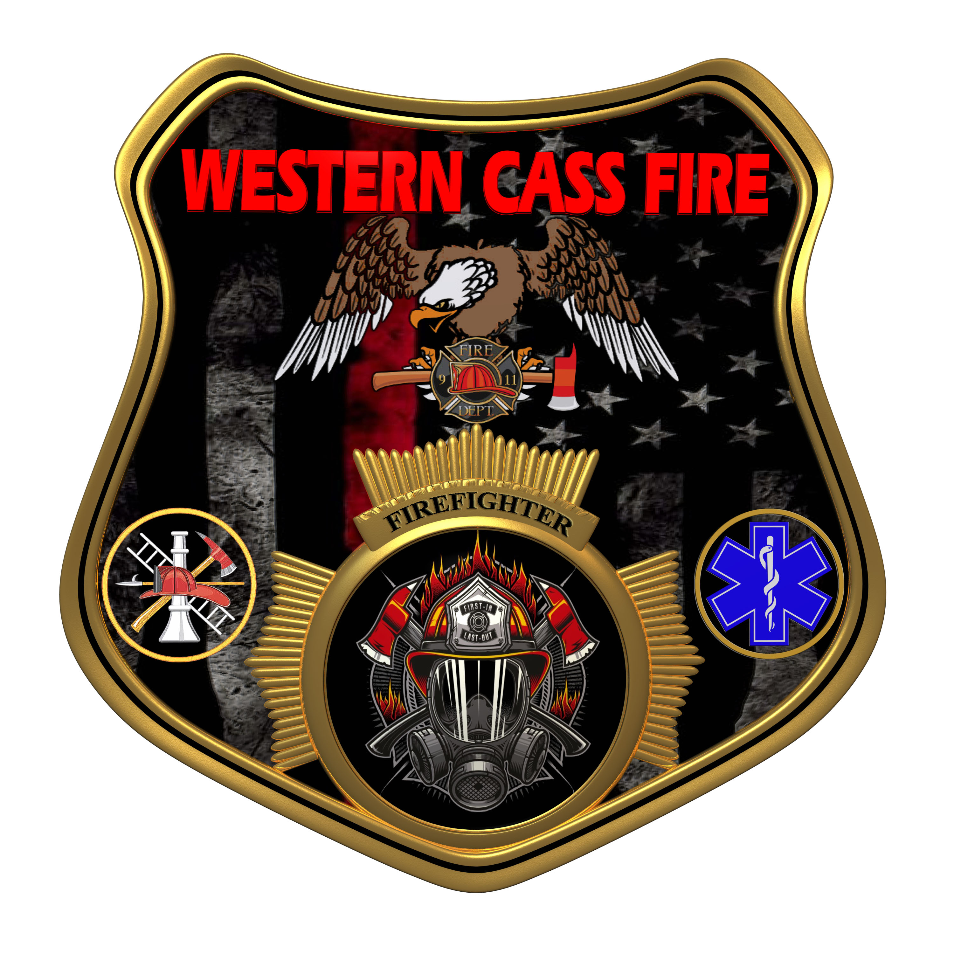 | Tentative Agenda  Western Cass Fire Protection District  Regular Session Meeting  Wednesday April 17, 2024, at 7:00 P.M.  Fire Headquarters  5 S. Rogers Road, Cleveland, MO 64734  Discussion Protocols and Organization Rules for Meetings:  Questions from the public must be in writing with the following information: Name, Phone #, Physical Address, Email Address.
- Call to Order by the Secretary
- Pledge of Allegiance
3) Roll Call (Quorum)
a) President Sue Hosterman (2019-2025)
b) Vice Chair John Webb (2022- 2027)
c) Director Tom Reintjes (2023- 2029)
d) Director Theresa Hawkins (2020-2025)
e) Director Mike Bigg (2021-2027)
4) Approve the Regular Session Meeting Tentative Agenda and Additions
5) Public Comments
6) Approve the March 20, 2024 Minutes
7) Reports
8) New Business
a) Policy 240417- 01 Billing for Services
b) Policy 240417- 02 “Spiller Pays”
c) Policy 240417- 03 Closed Records
d) Policy 240417- 04 Reoccurring Bill Pay
e) Preauthorized Payments (04-06-22 / Revised 03-25-24 by MB)
f) Custodian Billing
g) Tanker Replacement
9) Unfinished Business
a) IT Central
b) Website
c) Sunshine Policy
10) Closed Session – Personnel and Legal
Personnel matters are confidential until such time as they may be made public by the Board of Directors, and the nondisclosure of such records outweighs the public interest in disclosure of the records as according to RSMo 610.021(3)(13).
Legal matters are confidential until such time as they may be made public by the Board of Directors, and the nondisclosure of such records outweighs the public interest in disclosure of the records as according to RSMo 610.021(1)(3)(13)(19).
11) Adjourn

