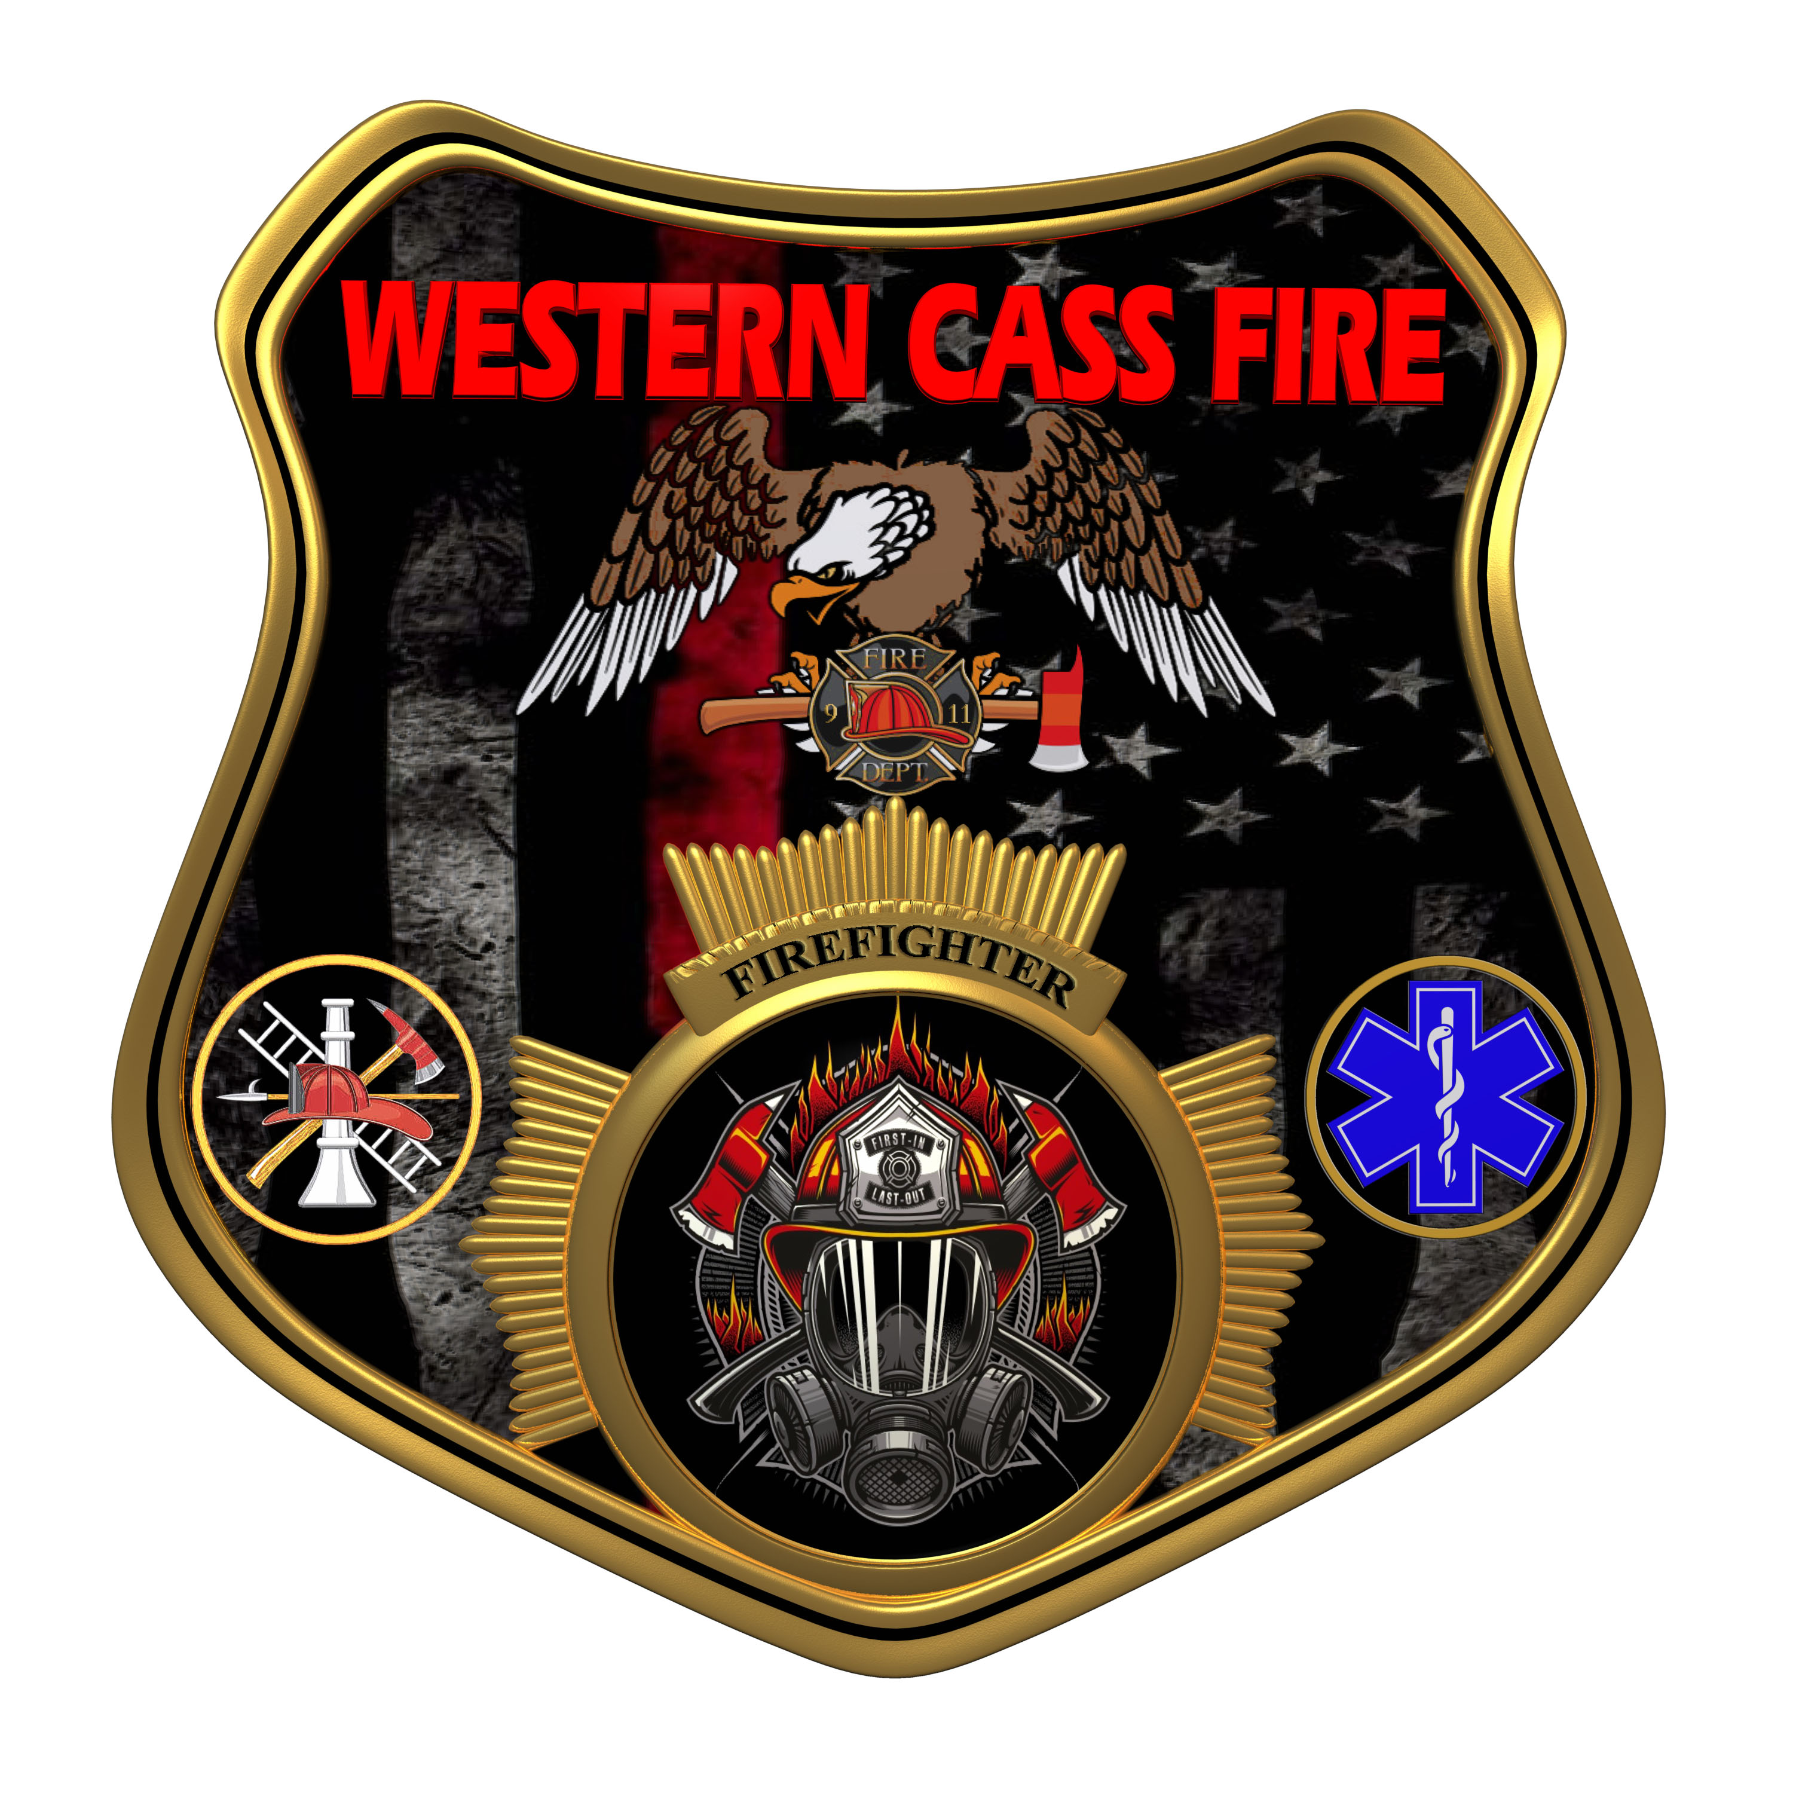 | Tentative Agenda  Western Cass Fire Protection District  Regular Session Meeting  Wednesday, January 18, 2023, at 7:00 pm  Fire Headquarters  5 S. Rogers Road, Cleveland, MO 64734  In Person Only  Discussion Protocols and Organization Rules for Meetings:  Questions from the public must be in writing with the following information: Name, Phone #, Physical Address, Email Address.  Board Members will be limited to 3 minutes for discussion of agenda items, twice per item, and discussion of items will last no more than 10 minutes per item.
- Call to Order by the Secretary
- Pledge of Allegiance
- Roll Call (Quorum)
a) President and Chair John Webb (2022- 2027)
b) Vice Chair Marty Hardman (2022- 2023)
c) Director Sue Hosterman (2019-2025)
d) Director Kerri VanMeveren (2020-2026)
e) Director Darvin Schildknecht (2021-2027)
- Adopt and Approve Wednesday, January 18, 2023 Tentative Agenda
- Approve the December 30, 2022 Special Session Minutes
- Corrections to November 16, 2022 Minutes
- Director Reports - Written Form
- Personal Appearances / Public Comments
9) Unfinished Business
a) Security Systems
b) Community Bank
10) New Business
1) Call for Elections
2) Year End Reconciliation
3) Chief Administrator Class
4) NIMS
11) Adjourn

