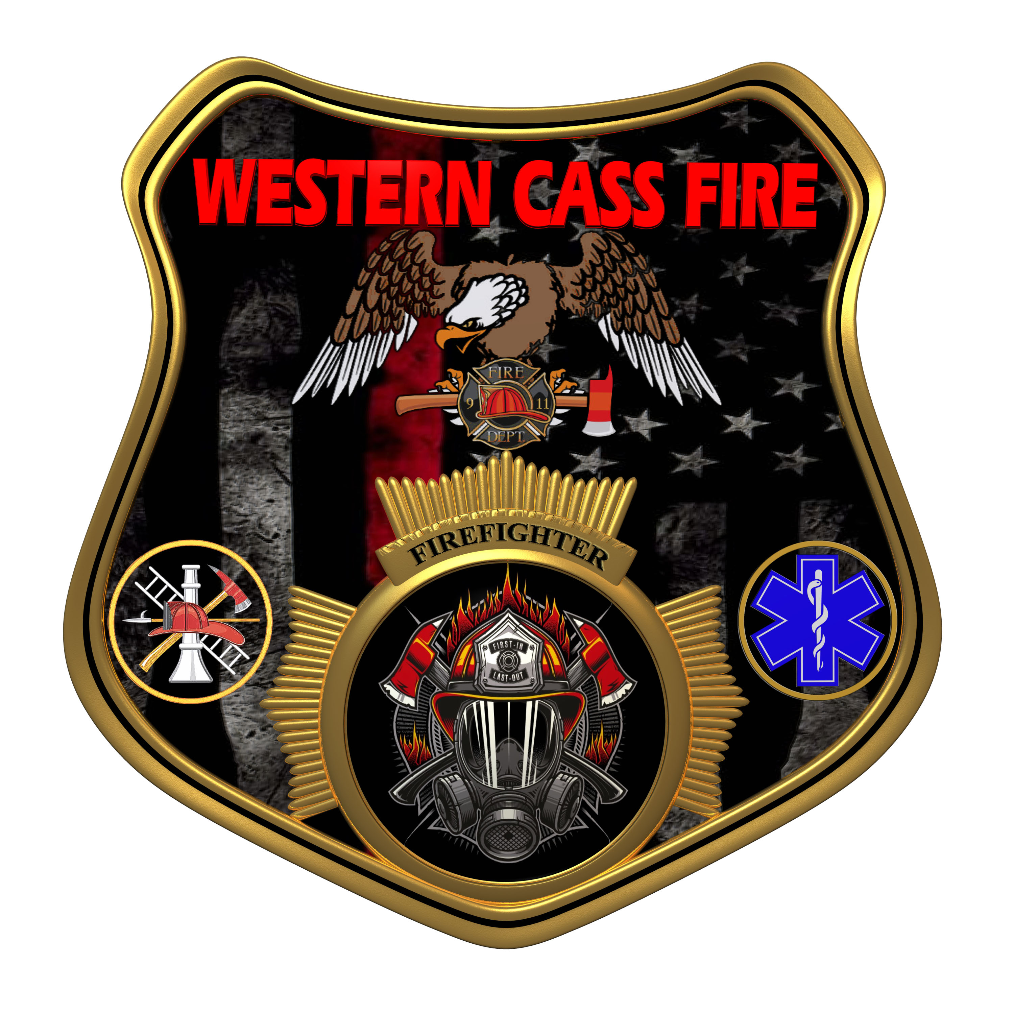 | Tentative Agenda  Western Cass Fire Protection District  Regular Session Meeting  Wednesday March 19, 2025, at 7:00 P.M.  Fire Headquarters  5 S. Rogers Road, Cleveland, MO 64734  Discussion Protocols and Organization Rules for Meetings:  Questions from the public must be in writing with the following information: Name, Phone #, Physical Address, Email Address.
- Call to Order by the Secretary
- Pledge of Allegiance
3) Roll Call (Quorum)
a) President Sue Hosterman (2019-2025)
b) Vice Chair John Webb (2022- 2027)
c) Director Tom Reintjes (2023- 2029)
d) Director Theresa Hawkins (2020-2025)
e) Director Mike Bigg (2021-2027)
4) Approve the Regular Session Meeting Tentative Agenda and Additions
5) Public Comments
6) Approve January 15, 2025 Regular Session Open and Closed Minutes, February 19, 2025 Regular Session Open and Closed Minutes, and February 26, 2025 Special Meeting Minutes
7) Reports
8) New Business
a) Election
b) C.P.A.
c) Mutual Aid
d) Consultant Invoice
e) Claim Policy
9) Unfinished Business
a) Grants Update
10) Closed Session: Personnel
Personnel matters are confidential until such time as they may be made public by the Board of Directors, and the nondisclosure of such records outweighs the public interest in disclosure of the records as according to RSMo 610.021(3)(13).
11) Return to Open Session
12) Adjournment

